# Import Procedure

To import the form created please follow the following procedures

1. Create a Cognito Forms account
2. Click this link to the template: <https://www.cognitoforms.com/templates/shared/marcobejarano1/findanimagingspecialist>
3. You will see a preview of the form, click “Use this Template”
4. You will be prompted to edit the following fields if needed:
   1. Title: Customize the title of the form
   2. Organization: If the user is a member of multiple organizations, they can select the organization where they want to save the form
5. After editing the required fields, you will be prompted to save the template and use it.

# Embedded Code Location

This is the location where the embedded code is located, and will need to be updated with the unique embedded code after importing the template:  
  
File: index.html

Lines: 92 - 96

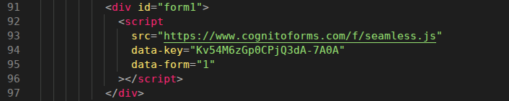

Replace with your unique seamless URL located in the publish area of the Cognito Forms builder. Here is a screenshot showing you that location(make sure it’s the seamless embedded code snippet):

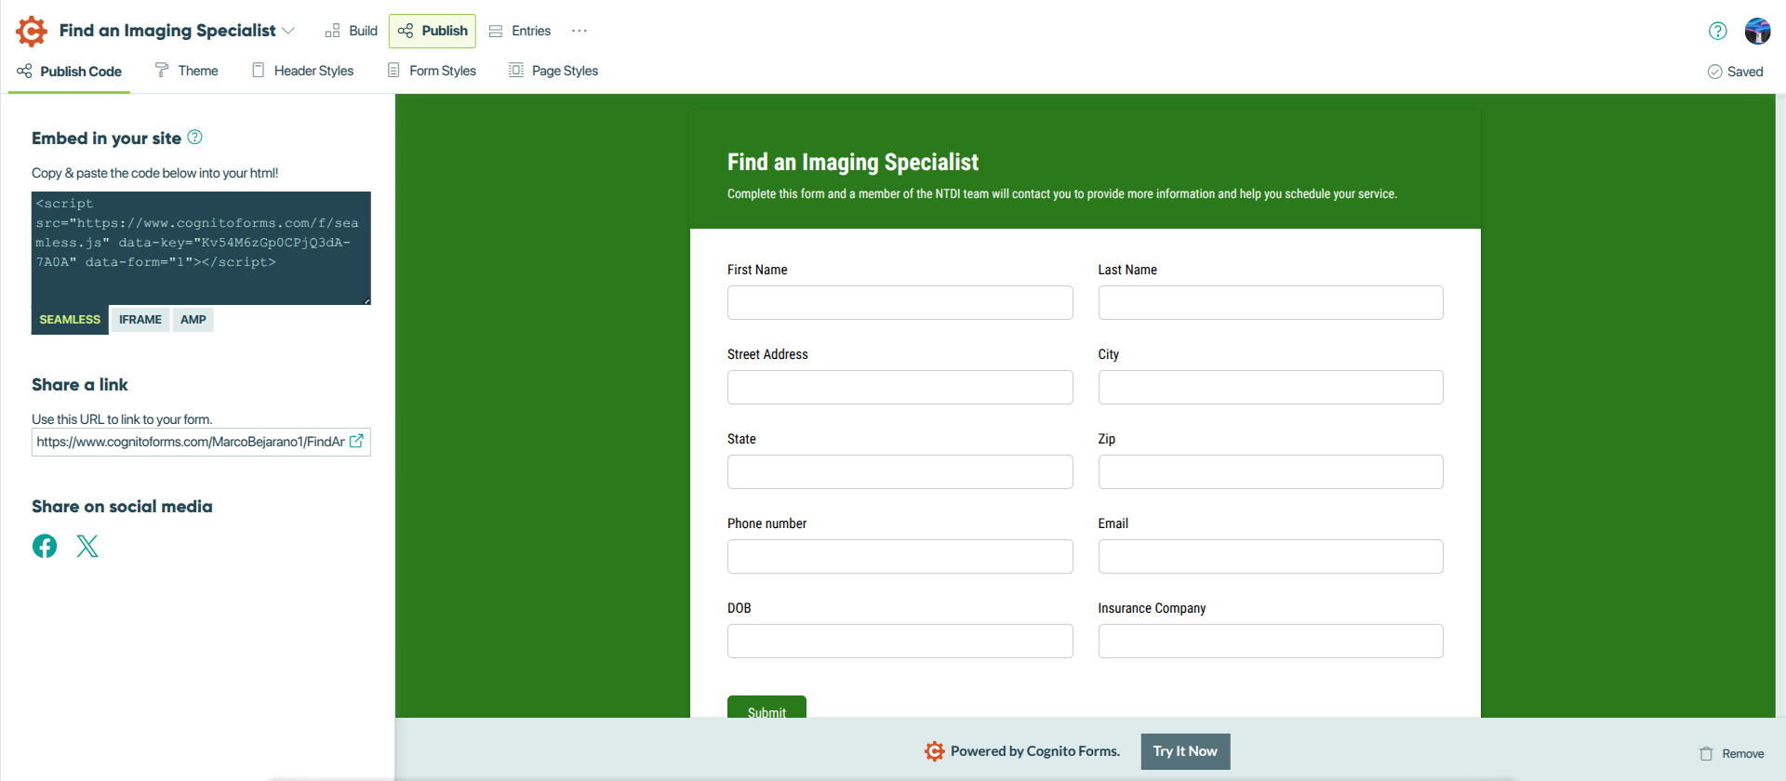

# Updating Fields and Workflow

All field names and data workflow will be updated within your Cognito Forms account. By default on submission the account holder will be notified by email on new entries.

# Changing Styling, Colors and Fonts

To change the colors you have the option of doing it within the Cognito Form builder and the form.css file. I recommend starting with the Cognito Forms option first, and then doing it with the CSS. The fonts as well can be changed in either Cognito Forms or the CSS. We currently are forcing Roboto via the form.css file so head there first.

—directory

—css

—form.css

—input.css

—output.css

—icons

—images

—about.html

—contact.html

—index.html

—services.html

—technology.html